TABLE OF CONTENTS

Sr. no. | NAME | PAGE NO.
 | Acknowledgement | 2
 | Introduction about project | 3
 | SDLC | 8
 | ABSTRACT | 12
 | INTRODUCTION ABOUT C++ | 13
 | ABOUT THE PROJECT | 23
 | SNAPSHOTS | 29
 | CONCLUSION | 42
 | SCOPE IN FUTURE | 43
 | BIBLIOGRAPHY | 44

ACKNOWLEDGEMENT

I have the honors to express my deep sense of gratitude to our project guide Er. Amarjit singh Lecturer Govt. Polytechnic college , Bhikhiwind. I made this project in minor project subject on c++ language. It would be my utmost pleasure to express my sincere thanks to My Teacher Er. Amarjit singh in providing a helping hand in this project. His patience, creativity and immense knowledge that he shared with me have proved highly beneficial to me and have made my Project File both possible and successful.

Introduction about the project

Automation is the use of control systems and information technologies to reduce the need for human work in the production of goods and services. In the scope of industrialization, automation is a step beyond mechanization. Whereas mechanization provided human operators with machinery to assist them with the muscular requirements of work, automation greatly decreases the need for human sensory and mental requirements as well. Automation plays an increasingly important role in the world economy and in daily experience.
Automation has had a notable impact in a wide range of industries beyond manufacturing (where it began). Once-ubiquitous telephone operators have been replaced largely by automated telephone switchboards and answering machines. Medical processes such as primary screening in electrocardiography or radiography and laboratory analysis of human genes, sera, cells, and tissues are carried out at much greater speed and accuracy by automated systems. Automated teller machines have reduced the need for bank visits to obtain cash and carry out transactions. In general, automation has been responsible for the shift in the world economy from industrial jobs to service jobs in the 20th and 21st centuries.

Advantages and disadvantages
The main advantages of automation are:
- Replacing human operators in tasks that involve hard physical or monotonous work.
- Replacing humans in tasks done in dangerous environments (i.e. fire, space, volcanoes, nuclear facilities, underwater, etc.)
- Performing tasks that are beyond human capabilities of size, weight, speed, endurance, etc.
- Economy improvement: Automation may improve in economy of enterprises, society or most of humanity. For example, when an enterprise invests in automation, technology recovers its investment; or when a state or country increases its income due to automation like Germany or Japan in the 20th Century.
The main disadvantages of automation are:
- Unemployment rate increases due to machines replacing humans and putting those humans out of their jobs.
- Technical Limitation: Current technology is unable to automate all the desired tasks.
- Security Threats/Vulnerability: An automated system may have limited level of intelligence, hence it is most likely susceptible to commit error.
- Unpredictable development costs: The research and development cost of automating a process may exceed the cost saved by the automation itself.
- High initial cost: The automation of a new product or plant requires a huge initial investment in comparison with the unit cost of the product, although the cost of automation is spread in many product batches of things.

Additional goals of automation

Reliability and precision
The old focus on using automation simply to increase productivity and reduce costs was seen to be short-sighted, because it is also necessary to provide a skilled workforce who can make repairs and manage the machinery. Moreover, the initial costs of automation were high and often could not be recovered by the time entirely new manufacturing processes replaced the old. (Japan's "robot junkyards" were once world famous in the manufacturing industry.)
Automation is now often applied primarily to increase quality in the manufacturing process, where automation can increase quality substantially. For example, automobile and truck pistons used to be installed into engines manually. This is rapidly being transitioned to automated machine installation, because the error rate for manual installment was around 1-1.5%, but has been reduced to 0.00001% with automation.

Health and environment
The costs of automation to the environment are different depending on the technology, product or engine automated. There are automated engines that consume more energy resources from the Earth in comparison with previous engines and those that do the opposite too. Hazardous operations, such as oil refining, the manufacturing of industrial chemicals, and all forms of metal working, were always early contenders for automation.

Convertibility and turnaround time
Another major shift in automation is the increased demand for flexibility and convertibility in manufacturing processes. Manufacturers are increasingly demanding the ability to easily switch from manufacturing Product A to manufacturing Product B without having to completely rebuild the production lines. Flexibility and distributed processes have led to the introduction of Automated Guided Vehicles with Natural Features Navigation.
Digital electronics helped too. Former analogue-based instrumentation was replaced by digital equivalents which can be more accurate and flexible, and offer greater scope for more sophisticated configuration, parametrization and operation. This was accompanied by the fieldbus revolution which provided a networked (i.e. a single cable) means of communicating between control systems and field level instrumentation, eliminating hard-wiring.
Discrete manufacturing plants adopted these technologies fast. The more conservative process industries with their longer plant life cycles have been slower to adopt and analogue-based measurement and control still dominates. The growing use of Industrial Ethernet on the factory floor is pushing these trends still further, enabling manufacturing plants to be integrated more tightly within the enterprise, via the internet if necessary. Global competition has also increased demand for Reconfigurable Manufacturing Systems.

Current limitations
Many roles for humans in industrial processes presently lie beyond the scope of automation. Human-level pattern recognition, language recognition, and language production ability are well beyond the capabilities of modern mechanical and computer systems. Tasks requiring subjective assessment or synthesis of complex sensory data, such as scents and sounds, as well as high-level tasks such as strategic planning, currently require human expertise. In many cases, the use of humans is more cost-effective than mechanical approaches even where automation of industrial tasks is possible. Overcoming these obstacles is a theorized path to post-scarcity economics.

,

Introduction to Systems development life-cycle (SDLC)

The systems development life cycle (SDLC), or software development life cycle in systems engineering, information systems and software engineering
is a process of creating or altering information systems, and the models and methodologies that people use to develop these systems.
In software engineering the SDLC concept underpins many kinds of software development methodologies. These methodologies form the framework for planning and controlling the creation of an information system: the software development process.

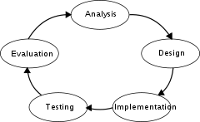

System analysis
The goal of system analysis is to determine where the problem is in an attempt to fix the system. This step involves breaking down the system in different pieces to analyze the situation, analyzing project goals, breaking down what needs to be created and attempting to engage users so that definite requirements can be defined.
Requirements analysis sometimes requires individuals/teams from client as well as service provider sides to get detailed and accurate requirements; often there has to be a lot of communication to and from to understand these requirements. Requirement gathering is the most crucial aspect as many times communication gaps arise in this phase and this leads to validation errors and bugs in the software program. The part of the system development life cycle with preliminary investigation which are made to understand the working of the existing system these investigation include the request system study, its clarification approval and the feasibility study of the system the system analysis collect the information of existing procedure and their working from this information find out the drawbacks in the system and finally present the solution of these problem

Design
In systems design the design functions and operations are described in detail, including screen layouts, business rules, process diagrams and other documentation. The output of this stage will describe the new system as a collection of modules or subsystems.
The design stage takes as its initial input the requirements identified in the approved requirements document. For each requirement, a set of one or more design elements will be produced as a result of interviews, workshops, and/or prototype efforts.
Design elements describe the desired software features in detail, and generally include functional hierarchy diagrams, screen layout diagrams, tables of business rules, business process diagrams, pseudocode, and a complete entity-relationship diagram with a full data dictionary. These design elements are intended to describe the software in sufficient detail that skilled programmers may develop the software with minimal additional input design.
The code is tested at various levels in software testing. Unit, system and user acceptance testings are often performed. This is a grey area as many different opinions exist as to what the stages of testing are and how much if any iteration occurs. Iteration is not generally part of the waterfall model, but usually some occur at this stage. In the testing the whole system is test one by one
Following are the types of testing:
- Defect testing the failed scenarios, including defect tracking
- Path testing
- Data set testing
- Unit testing
- System testing
- Integration testing
- Black-box testing
- White-box testing
- Regression testing
- Automation testing
- User acceptance testing
- Performance testing

Operations and maintenance
The deployment of the system includes changes and enhancements before the decommissioning or sunset of the system. Maintaining the system is an important aspect of SDLC. As key personnel change positions in the organization, new changes will be implemented, which will require system updates.

ABSTRACT

This project aims at developing into software that can be used at places likerestaurants and fastfood points to easily manoeuvre the daily tasks of taking the order, calculating the bill etc.
This project is time saving as it saves the time of the workers as well as customers. It calculates bill quickly and correctly. Modification of the details of the items in the menu, addition of more items in the menu, deletion of items and keeping up of the track of the items purchased is much more convenient.

INTRODUCTION OF C++ :

During the 1980s and into the 1990s, an explosive growth in object-oriented technology began with the introduction of the Smalltalk language. Object-Oriented Programming (OOP) began to replace the more traditional structured programming techniques. This explosion led to the development of languages which support programming with objects. Many new object-oriented programming languages appeared: Object-Pascal, Modula-2, Mesa, Cedar, Neon, Objective-C, LISP with the Common List Object System (CLOS), and, of course, C++. Although many of these languages appeared in the 1980s, many ideas of OOP were taken from Simula-67. Yes! OOP has been around since 1967.
C++ originated with Bjarne Stroustrop. In the simplest sense, if not the most accurate, we can consider it to be a better C. Although it is not an entirely new language, C++ represents a significant extension of C abilities. We might then consider C to be a subset of C++. C++ supports essentially every desirable behavior and most of the undesirable ones of its predecessor, but provides general language improvements as well as adding OOP capability. This tutorial is a collection of lectures to be held in the on-line course Introduction to Object-Oriented Programming Using C++ . In this course, object-orientation is introduced as a new programming concept which should help you in developing high quality software. Object-orientation is also introduced as a concept which makes developing of projects easier. However, this is not a course for learning the C++ programming language. If you are interested in learning the language itself, you might want to go through other tutorials, such as C++: Annotations by Frank Broken and Karel Kubat. In this tutorial only those language concepts that are needed to present coding examples are introduced. And what makes object-orientation such a hot topic? To be honest, not everything that is sold under the term of object-orientation is really new. For example, there are programs written in procedural languages like Pascal or C which use object-oriented concepts. But there exist a few important features which these languages won't handle or won't handle very well, respectively. Some people will say that object-orientation is ``modern''. When reading announcements of new products everything seems to be ``object-oriented''. ``Objects'' are everywhere. In this tutorial we will try to outline characteristics of object-orientation to allow you to judge those object-oriented products.
The designers of C++ wanted to add object-oriented mechanisms without compromising the efficiency and simplicity that made C so popular. One of the driving principles for the language designers was to hide complexity from the programmer, allowing her to concentrate on the problem at hand. Because C++ retains C as a subset, it gains many of the attractive features of the C language, such as efficiency, closeness to the machine, and a variety of built-in types. A number of new features were added to C++ to make the language even more robust, many of which are not used by novice programmers. By introducing these new features here, we hope that you will begin to use them in your own programs early on and gain their benefits. Some of the features we will look at are the role of constants, inline expansion, references, declaration statements, user defined types, overloading, and the free store. Most of these features can be summarized by two important design goals: strong compiler type checking and a user-extensible language. By enforcing stricter type-checking, the C++ compiler makes us acutely aware of data types in our expressions. Stronger type checking is provided through several mechanisms, including: function argument type checking, conversions, and a few other features we will examine below.
C++ also enables programmers to incorporate new types into the language, through the use of classes. A class is a user-defined type. The compiler can treat new types as if they are one of the built-in types. This is a very powerful feature. In addition, the class provides the mechanism for data abstraction and encapsulation, which are key to object-oriented programming. As we examine some of the new features of C++ we will see these two goals resurface again and again.
BASIC CONCEPT OF OBJECT ORIENTED PROGRAMMING
Class
A class is an actual representation of an ADT. It therefore provides implementation details for the data structure used and operations. We play with the ADT Integer and design our own class for it:
class Integer {
attributes:
int i

methods:
setValue(int n)
Integer addValue(Integer j)
}
In the example above as well as in examples which follow we use a notation which is not programming language specific. In this notation class {...} denotes the definition of a class. Enclosed in the curly brackets are two sections attributes: and methods: which define the implementation of the data structure and operations of the corresponding ADT. Again we distinguish the two levels with different terms: At the implementation level we speak of ``attributes'' which are elements of the data structure at the ADT level. The same applies to ``methods'' which are the implementation of the ADT operations.
Abstract Classes
With inheritance we are able to force a subclass to offer the same properties like their superclasses. Consequently, objects of a subclass behave like objects of their superclasses.
Sometimes it make sense to only describe the properties of a set of objects without knowing the actual behaviour beforehand. In our drawing program example, each object should provide a method to draw itself on the drawing area. However, the necessary steps to draw an objects depends on its represented shape. For example, the drawing routine of a circle is different from the drawing routine of a rectangle.

Objects
C++ introduces object-oriented (OO) features to C. It offers classes, which provide the four features commonly present in OO (and some non-OO) languages: abstraction, encapsulation, inheritance, and polymorphism. Objects are instances of classes created at runtime. The class can be thought of as a template from which many different individual objects may be generated as a program runs.
Encapsulation
Encapsulation is the hiding of information in order to ensure that data structures and operators are used as intended and to make the usage model more obvious to the developer. C++ provides the ability to define classes and functions as its primary encapsulation mechanisms. Within a class, members can be declared as either public, protected, or private in order to explicitly enforce encapsulation. A public member of the class is accessible to any function. A private member is accessible only to functions that are members of that class and to functions and classes explicitly granted access permission by the class ("friends"). A protected member is accessible to members of classes that inherit from the class in addition to the class itself and any friends.
The OO principle is that all of the functions (and only the functions) that access the internal representation of a type should be encapsulated within the type definition. C++ supports this (via member functions and friend functions), but does not enforce it: the programmer can declare parts or all of the representation of a type to be public, and is allowed to make public entities that are not part of the representation of the type. Because of this, C++ supports not just OO programming, but other weaker decomposition paradigms, like modular programming.
It is generally considered good practice to make all data private or protected, and to make public only those functions that are part of a minimal interface for users of the class. This hides all the details of data implementation, allowing the designer to later fundamentally change the implementation without changing the interface in any way.
Inheritance
Inheritance allows one data type to acquire properties of other data types. Inheritance from a base class may be declared as public, protected, or private. This access specifier determines whether unrelated and derived classes can access the inherited public and protected members of the base class. Only public inheritance corresponds to what is usually meant by "inheritance". The other two forms are much less frequently used. If the access specifier is omitted, a "class" inherits privately, while a "struct" inherits publicly. Base classes may be declared as virtual; this is called virtual inheritance. Virtual inheritance ensures that only one instance of a base class exists in the inheritance graph, avoiding some of the ambiguity problems of multiple inheritance.
Multiple inheritance is a C++ feature sometimes considered controversial. Multiple inheritance allows a class to be derived from more than one base class; this can result in a complicated graph of inheritance relationships. For example, a "Flying Cat" class can inherit from both "Cat" and "Flying Mammal". Some other languages, such as Java or C#, accomplish something similar (although more limited) by allowing inheritance of multiple interfaces while restricting the number of base classes to one (interfaces, unlike classes, provide only declarations of member functions, no implementation or member data). Interfaces and abstract classes in Java and C# can be approximated in C++ as a class containing only function declarations, often known as an abstract base class or "ABC." Programmers preferring the Java/C# model of inheritance can choose to inherit only one non-abstract class, although in this case the declared member functions of the abstract base classes must be explicitly defined and cannot be inherited.
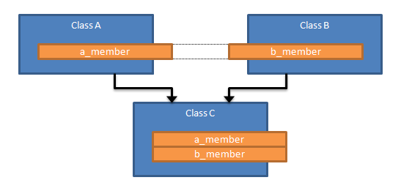
Multiple inheritance
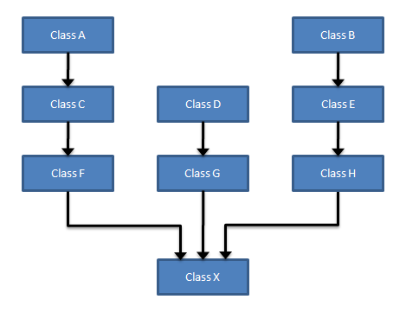

Polymorphism
Polymorphism enables one common interface for many implementations, and for objects to act differently under different circumstances.
C++ supports several kinds of static (compile-time) and dynamic (run-time) polymorphisms. Compile-time polymorphism does not allow for certain run-time decisions, while run-time polymorphism typically incurs a performance penalty.
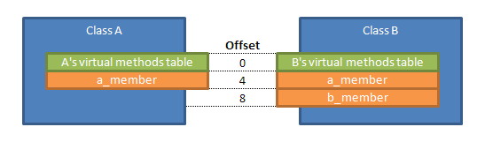

Static polymorphism
Function overloading allows programs to declare multiple functions having the same name (but with different arguments). The functions are distinguished by the number and/or types of their formal parameters. Thus, the same function name can refer to different functions depending on the context in which it is used. The type returned by the function is not used to distinguish overloaded functions.
When declaring a function, a programmer can specify default arguments for one or more parameters. Doing so allows the parameters with defaults to optionally be omitted when the function is called, in which case the default arguments will be used. When a function is called with fewer arguments than there are declared parameters, explicit arguments are matched to parameters in left-to-right order, with any unmatched parameters at the end of the parameter list being assigned their default arguments. In many cases, specifying default arguments in a single function declaration is preferable to providing overloaded function definitions with different numbers of parameters.
Templates in C++ provide a sophisticated mechanism for writing generic, polymorphic code. In particular, through the Curiously Recurring Template Pattern it's possible to implement a form of static polymorphism that closely mimics the syntax for overriding virtual functions. Since C++ templates are type-aware and Turing-complete they can also be used to let the compiler resolve recursive conditionals and generate substantial programs through template metaprogramming.
Dynamic polymorphism
C++ also provides a dynamic_cast operator, which allows the program to safely attempt conversion of an object into an object of a more specific object type (as opposed to conversion to a more general type, which is always allowed). This feature relies on run-time type information (RTTI). Objects known to be of a certain specific type can also be cast to that type with static_cast, a purely compile-time construct which is faster and does not require RTTI.

ABOUT PROJECT

A restaurant is a retail establishment that serves prepared food to customers Service is generally for eating on premises, though the term has been used to describe take-out establishments and food delivery services. The term covers many types of venues and a diversity of styles of cuisine and service.
A restaurant owner is called a restaurateur; both words derive from the French verb restaurer, meaning to restore.
“FOOD AUTOMATION” aims at developing into software that can be used at places like restaurants and fastfood points to easily manoeuvre the daily tasks of taking the order, calculating the bill etc.
The main advantage of this project is that it converts all the manual work which is time consuming and error prone to fully automated system which helps in eliminating all the paper work, saves time, improves customer services. It also speeds up various processes such as addition of new items to the menu, deletion of items from the menu, modification of details of items and calculation of bills thus providing convenience to the workers as well as customers.

WORKING DESCRIPTION OF PROJECT

This project mainly consists of two menus:

EDIT MENU
MAIN MENU
Edit menu consists of the following available options:
ADD ITEM
DELETE ITEM
MODIFY ITEM
QUIT
MAIN MENU
It consists of the following options
1 PURCHASE
2 SEE MENU
3 EDIT MENU
4 TOTAL BILL
0 QUIT
ENTER CHOICE
Now here when we choose the first option i.e. PURCHASE, we need to mention the item code of the item to be purchased. After this the complete details of the item is displayed. Then we are required to mention the quantity, whether we want to cancel this purchase or not
After this total bill is calculated and displayed along with the complete details of items.
When we choose the second option i.e. SEE MENU, following details of the list of items is displayed:

1. ITEM CODE
2. ITEM NAME
3. ITEM COST
4. ITEM PRICE

Now when we choose the third option EDIT MENU following options are dislayed:

ADD ITEM
MODIFY ITEM
DELETE ITEM
EXIT
ENTER CHOICE:
Now here when we choose the first option i.e. ADD ITEM, we need to specify the following details of the item:
ITEM NAME
ITEM COST
ITEM PRICE
Thereafter we have to decide whether we want to save the record or not and hence choose one of the options: y/n. When we choose your record is saved otherwise not. Then we add more items according to the requirement.
Now when we choose the second option i.e. MODIFY ITEM, we need to specify the item code of the item to be selected and then modify the details of the items as per the requirement by choosing the correct options.
When we choose the third option i.e. DELETE ITEM, we need to specify the item code of the item to be deleted. Thereafter the selected item is deleted from the menu.
We can choose the fourth option i.e. EXIT to exit the menu.
We can choose the fourth option of the main menu i.e. TOTAL BILL to display the total bill of the items purchased
HEADER FILES USED AND THEIR PURPOSE
FSTREAM.H – for file handling, cin and cout
- PROCESS.H – for exit() function
- CONIO.H – for clrscr() and getch() functions
- STDIO.H – for standard I/O operations
- DOS.H – for execution of program
- STRING.H – for string handling
- GRAPHICS.H – for graphical display

FILES GENERATED

DATA FILES
FOOD.DAT

PROGRAM FILE
FOOD.CPP

OBJECT FILE
FOOD.OBJ

EXECUTION FILE
FOOD.EXE

PROGRAM OUTPUT :-

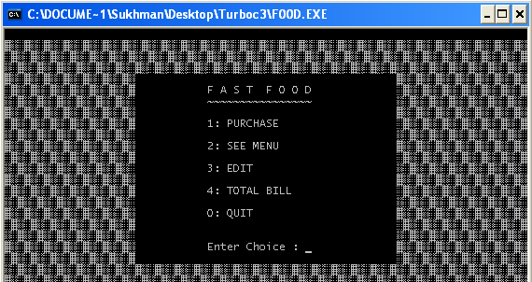

When enter our choice :1
Output obtained by choosing the first option Purchase item then enter the item code we want to be purchase.

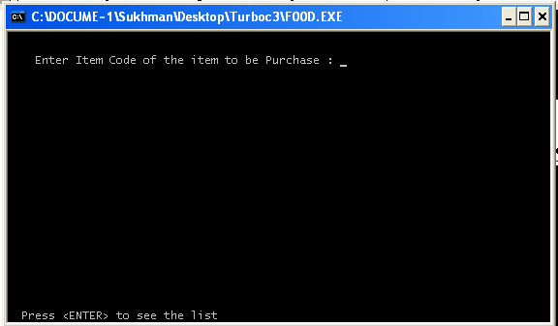

Then enter the quantity of item.

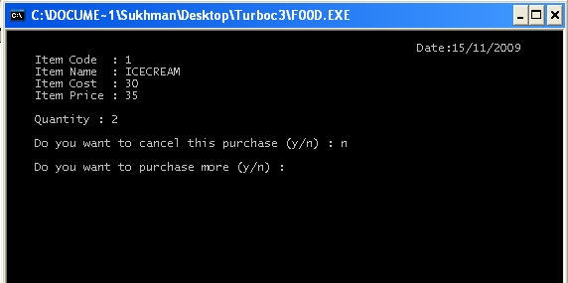

Calculated bill is then displayed as shown below:

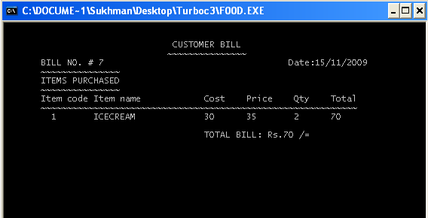

when enter our choice :2
Output obtained by choosing the second option see menu then list of item is obtained.

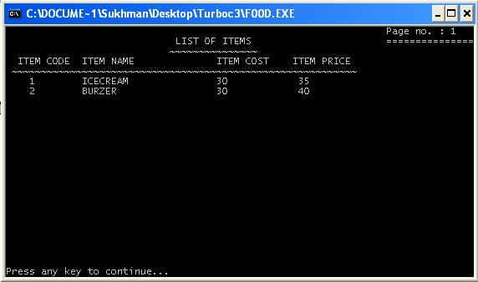

When we choosing the third option edit menu we get following :-

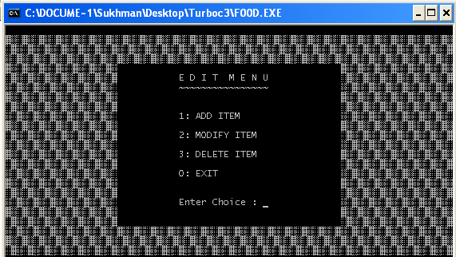

if enter our choice :1
After choosing add item we get following

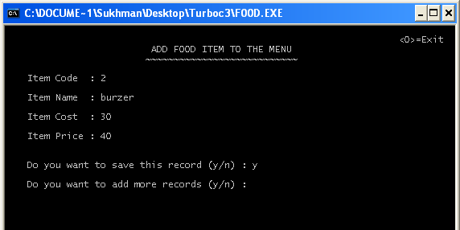

Output obtained by choosing modify item then enter our choice :2

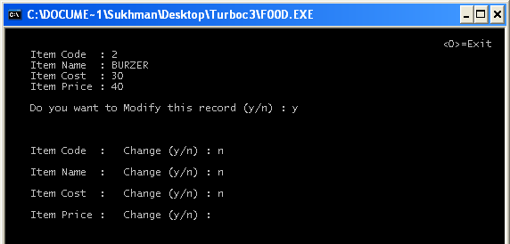

Output obtained by choosing delete item then enter our choice:3
When we delete the item then enter code of item.

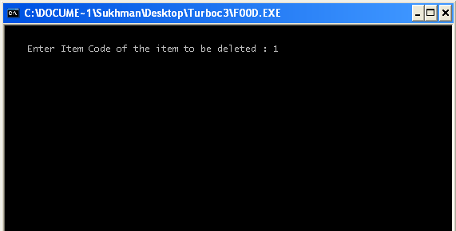

After this Following output will be displayed

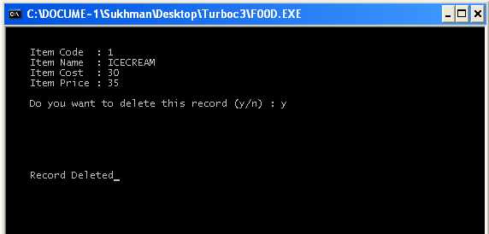

When enter our choice : 0 then exit from the edit menu.

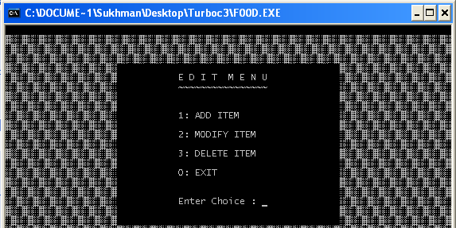

When enter our choice : 4 ,We can be see list of all bills in detail.

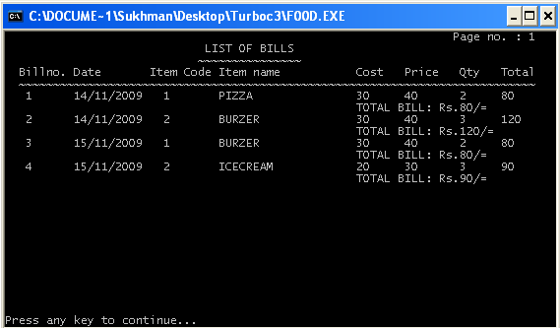

When enter our choice : 0 ,then quit from the fast food automation program.

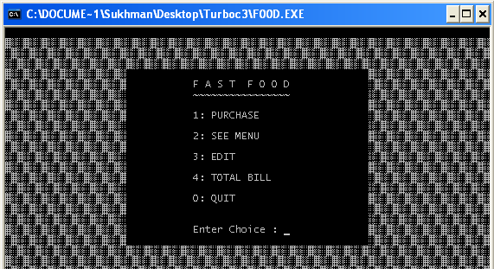

Conclusion

As we all know that a restaurant is a retail establishment that serves preparedfood to customers. Service is generally for eating on premises, though the term has been used to describe take-out establishments and food delivery services. So this project basically develops a software that can be used at such places to easily manoeuvre the daily tasks of taking the order, calculating the bill, modifying the details of the items in the menu etc. This project is time saving as it saves the time of the workers as well as customers. It calculates bill quickly and correctly. Modification of the details of the items in the menu, addition of more items in the menu, deletion of items and keeping up of the track of the items purchased is much more convenient.

SCOPE IN FUTURE

It is also storage saving .Previously all the work was done manually and required a lot of time. Tedious book-keeping is completely eliminated with automation. Large amount can be stored in a single hard Disk and make it easy for the user to store data for future retrieval. The storage enhancement provide benefit in the form of cost saving. Complicated calculations can be done more easily. Thus bills can be prepared more quickly and with more accuracy just by choosing the correct option which calculates the bill automatically.

BIBLIOGRAPHY

- Books

- Object Oriented Programming using C++ by :-

Robert Lafore

- Object Oriented Programming using C ++ by:-

Hemant kapila.

Websites:

- WWW.BOTSKOOL.COM
- WWW.WIKIPEDIA.COM

